***User Manual***

1. Description

This game require 2 players, each player will take turn to input a single (4 bits) number. The first player will start out with the switches SW0 – SW3 with SW0 being the least significant bit. After the first player input the first number, the number will show up in the 7 segments display HEX3. After this, it is player 2 turn. The player 2 will input another number using switches SW14 – SW17 with SW14 being the least significant bit. After the second player input the number, their number will show up in the 7 segments display HEX6. Each time the player input a number, the sum of both number from player one and player two will show up in 7 segments display HEX5. All the number show up in the 7 segments display will be in base 16.

1. User Manual in Pictures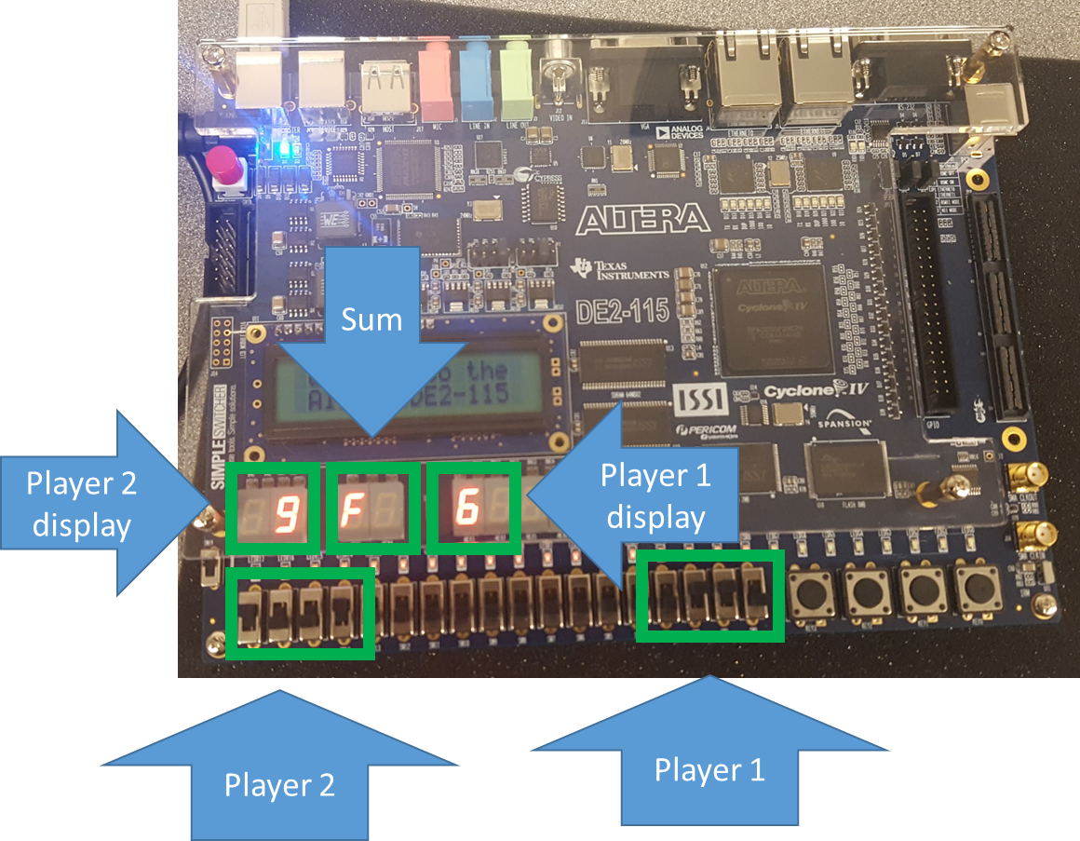

Figure 1: Controller layout.

1. How-to guide
   1. First player input the first number (see Section II).
   2. Second player input the next number.
   3. The goal is to get the second player to input a number so that the sum of two number will be a matching pair meaning the number will add up to 1111, this will be shown as F on the board. Below is a picture of a successful attempt. 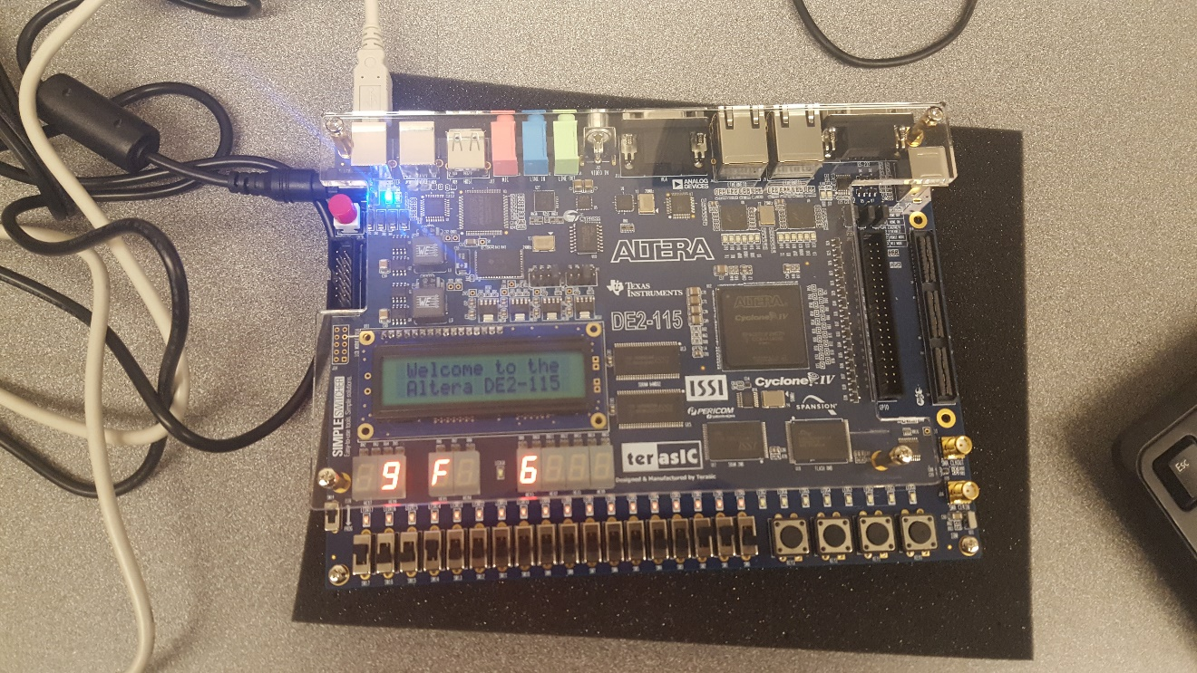

Figure 2: Successful attempt.

* 1. Below is a picture of a fail attempt when the 2 number won’t add up to 1111. 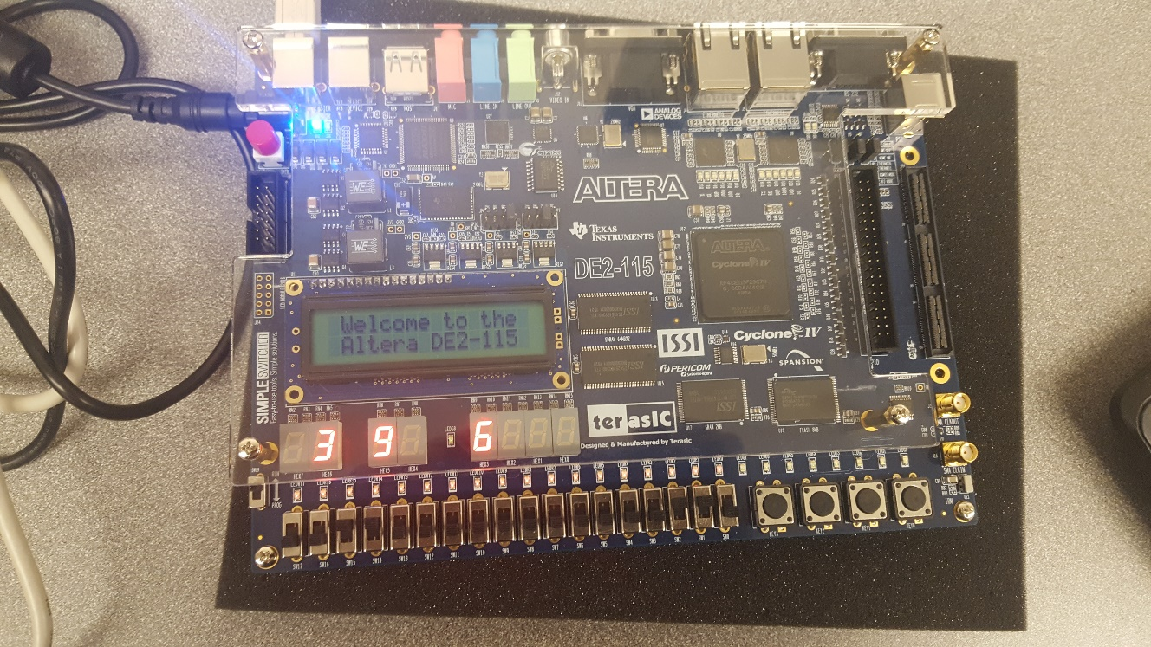

Figure 3: Fail attempt